EXPERIMENT NO. 07
DESIGN AND SIMULATION OF HALF ADDER USING STATIC CMOS
―――――――――――――――――――――――――――――――――――――――――――――――――――――――
AIM
To design and simulate a Half Adder circuit using static CMOS design style in LT Spice.
SOFTWARE USED
LT Spice
CIRCUIT DIAGRAM
Logic architecture and transistor-level CMOS schematic for the Half Adder:
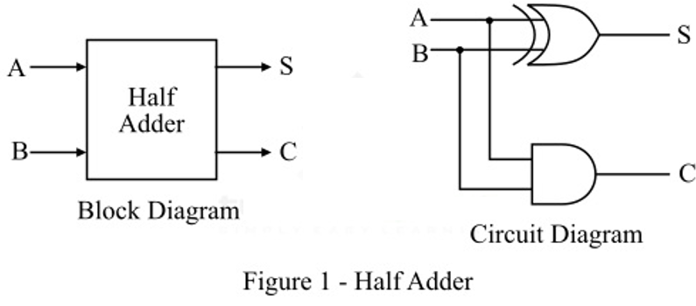
Figure 7.1: Block Diagram and Logic Circuit of Half Adder
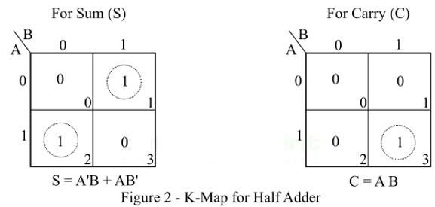
Figure 7.2: Karnaugh Map (K-Map) for Sum (S) and Carry (C)
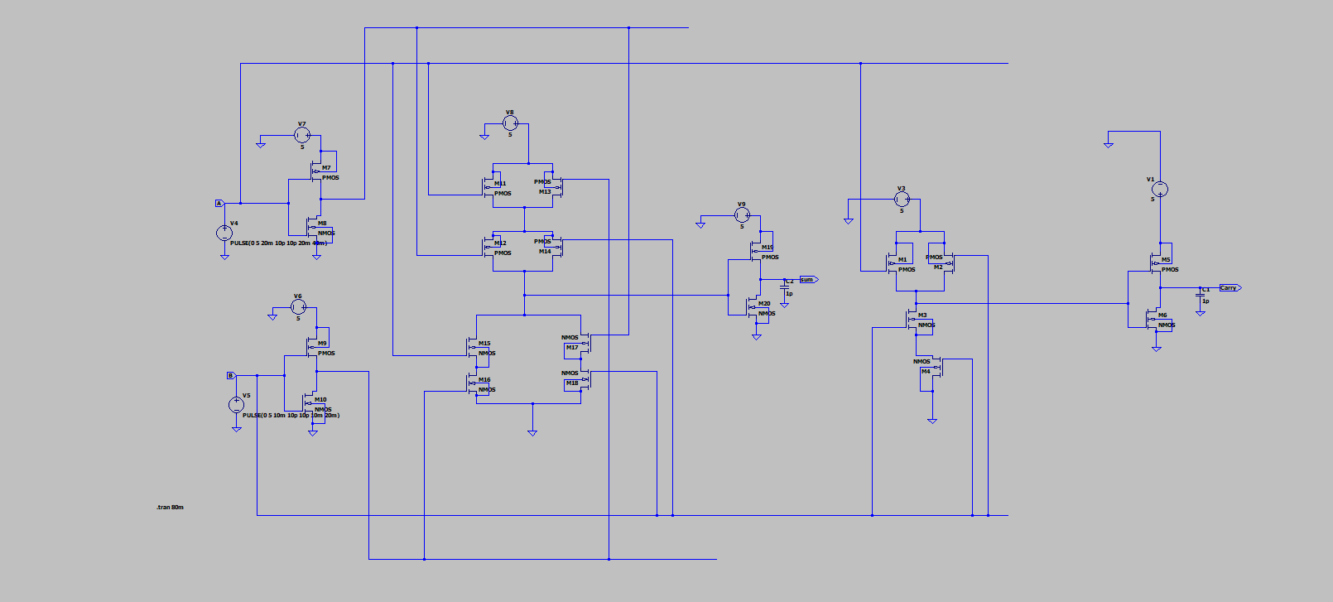
Figure 7.3: Transistor-Level Static CMOS Half Adder Schematic in LT Spice
SMALL THEORY
A Half Adder is a foundational combinational arithmetic block designed to calculate the binary addition of two single-bit inputs A and B. It produces two output bits: Sum (S) and Carry (C).
- Binary Addition Rules: 0 + 0 = 0 (Sum = 0, Carry = 0)
0 + 1 = 1 (Sum = 1, Carry = 0)
1 + 0 = 1 (Sum = 1, Carry = 0)
1 + 1 = 10 (Sum = 0, Carry = 1)
- Characteristic Equations: Sum (S) = A ⊕ B = A·B' + A'·B
- Carry (C) = A · B
- CMOS Implementation: In static CMOS design, the Sum output is realized using a complementary XOR stage, and Carry is realized using a static NAND gate followed by an inverter. Both circuits feature high noise margins, robust pull-up/pull-down switching, and rail-to-rail output swing.
Truth Table for Half Adder:
Input A | Input B | Sum (S) | Carry (C)
0 | 0 | 0 | 0
0 | 1 | 1 | 0
1 | 0 | 1 | 0
1 | 1 | 0 | 1

OUTPUT GRAPH
Transient simulation waveforms verifying the half adder truth table in LT Spice:
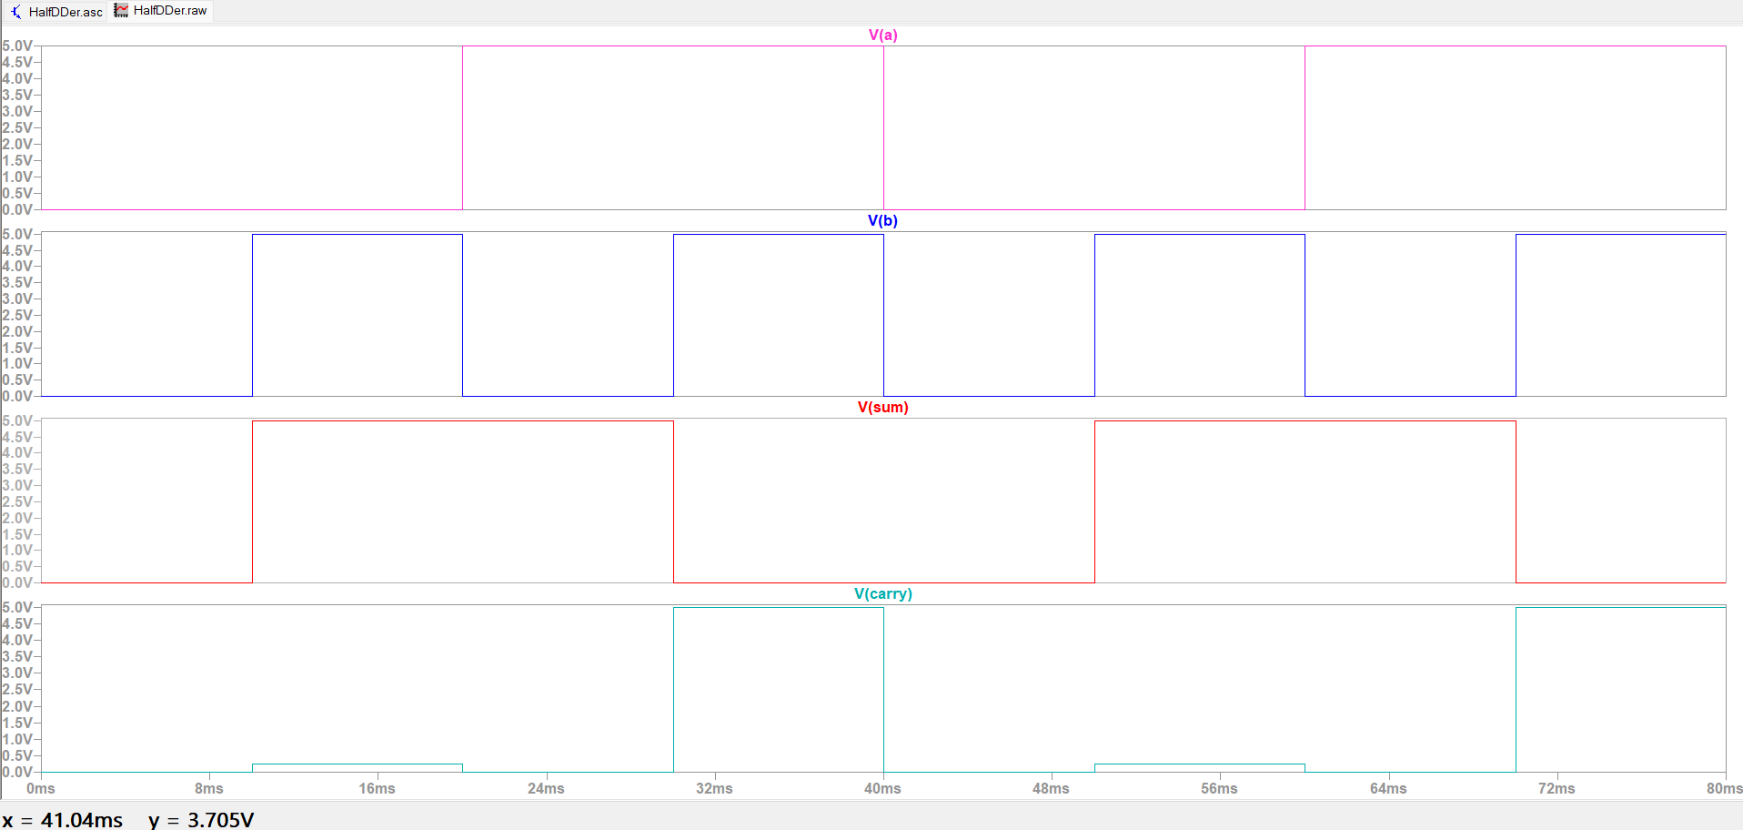
Figure 7.4: LT Spice Waveforms for Inputs V(a), V(b) and Outputs V(sum), V(carry)

